Module Name: Login
Test Case ID: SD_TC_001
● Scenario ID: 1a
Scenario: Verify OrangeHRM Login Page Loads
Test Steps: 1. Open the OrangeHRM demo URL and verify the login page loads successfully.
Scareenshots:
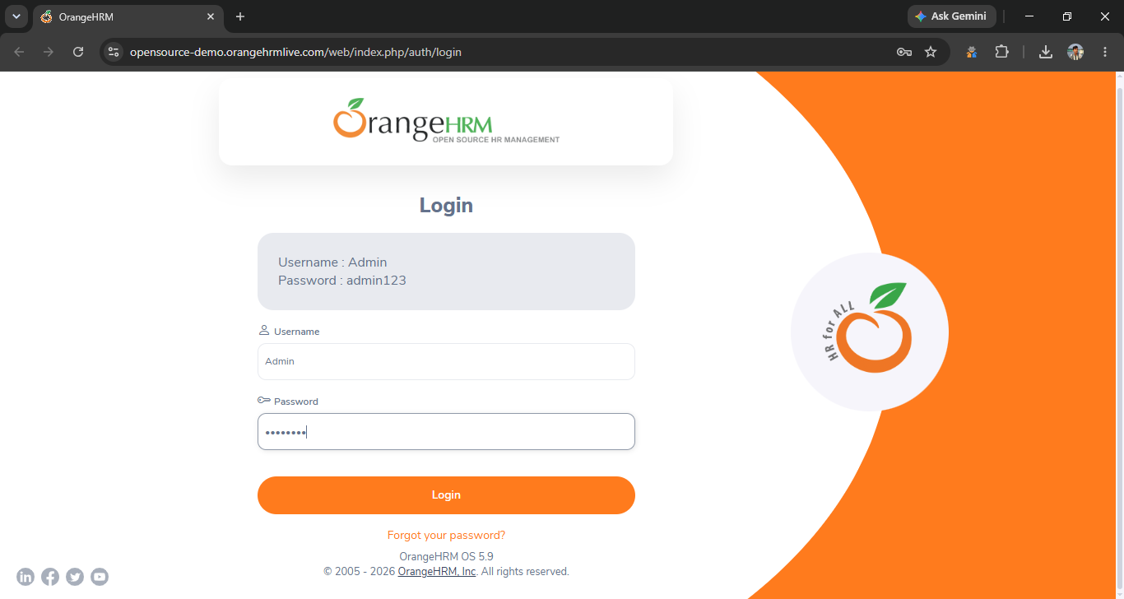
● Scenario ID: 1b
Scenario: Verify Login with Valid Credentials
Test Steps: 1. Enter valid username and password, then click Login.
Screen sort
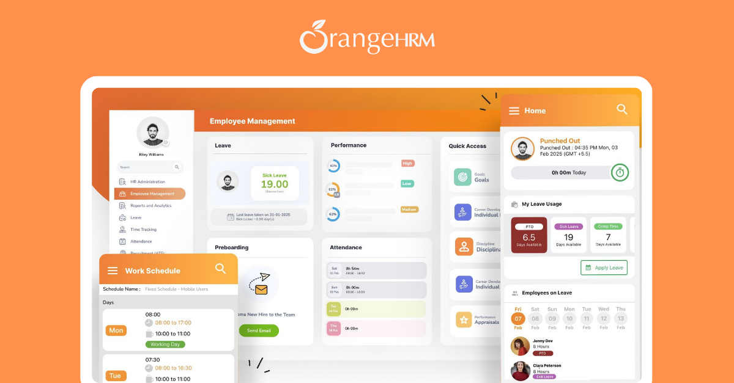

● Scenario ID: 1c
Scenario: Verify Login with Invalid Password
Test Steps: 1. Enter a valid username with an incorrect password, then click Login.
Screen sort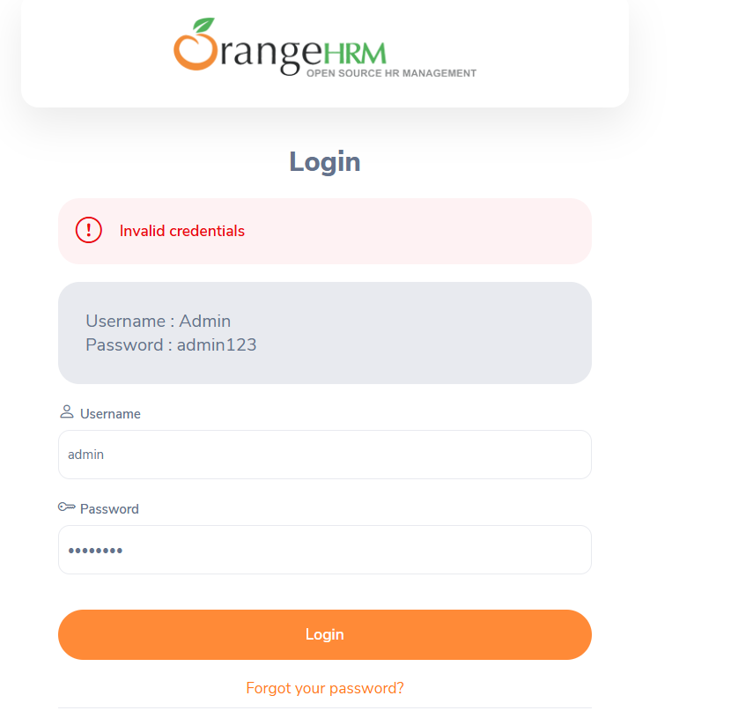
● Scenario ID: 1d
Scenario: Verify Login with Invalid Username
Test Steps: 1. Enter a non-existing username with a password, then click Login (notarealuser / admin123)
Screen sort
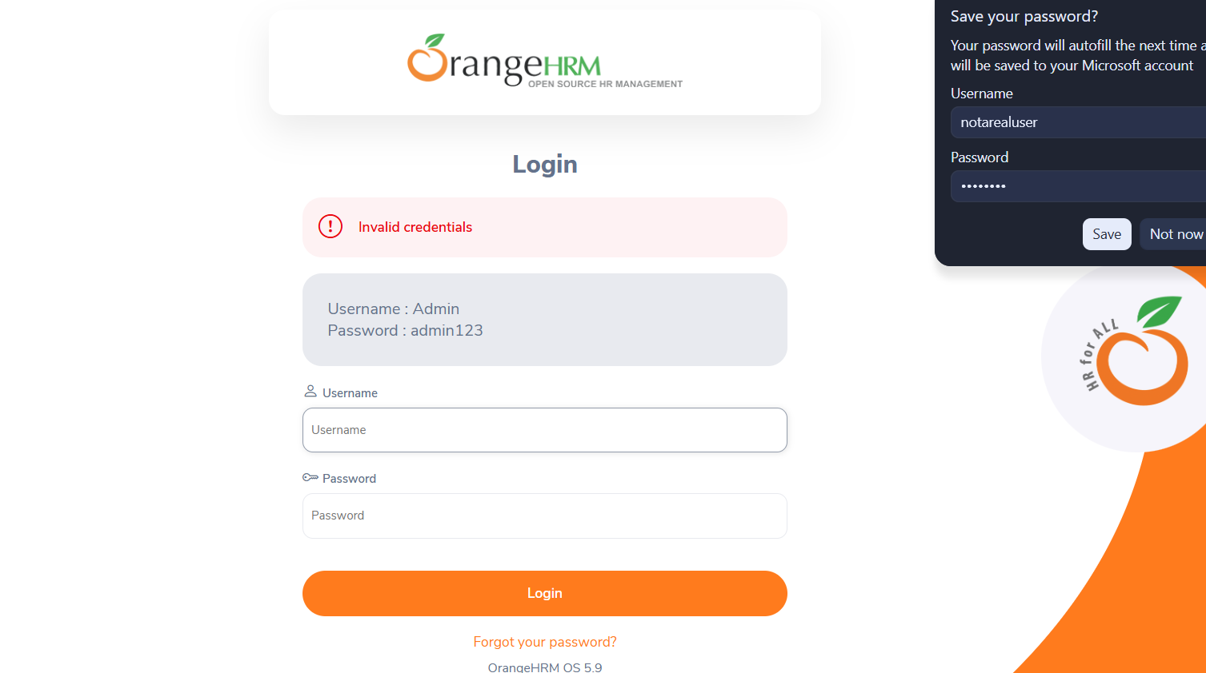
● Scenario ID: 1e
Scenario: Verify Login with Blank Username and Password
Test Steps: 1. Leave both Username and Password fields blank, then click Login.
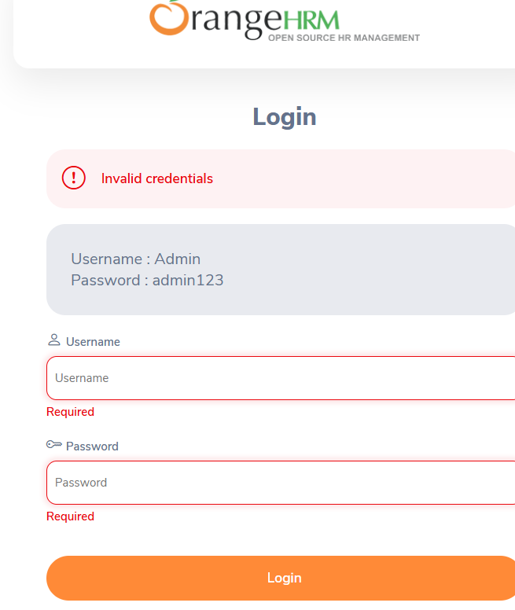
Screen sort

● Scenario ID: 1f
Scenario: Verify Login with Blank Password Only
Test Steps: 1. Enter a valid username and leave the Password field blank, then click Login.

Screen sort
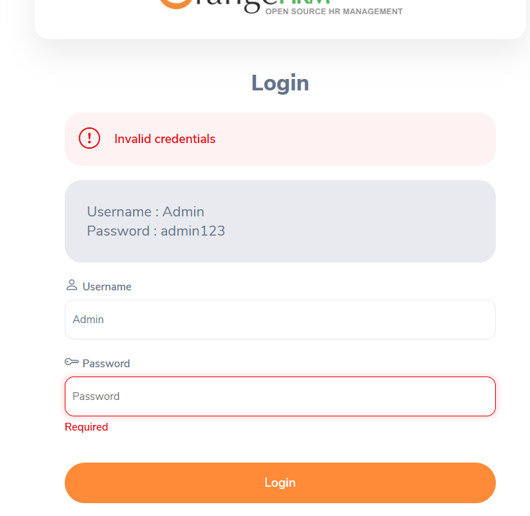

● Scenario ID: 1g
Scenario: Verify 'Forgot Your Password?' Link
Test Steps: 1 Click the 'Forgot your password?' link on the login page.
Screen sort
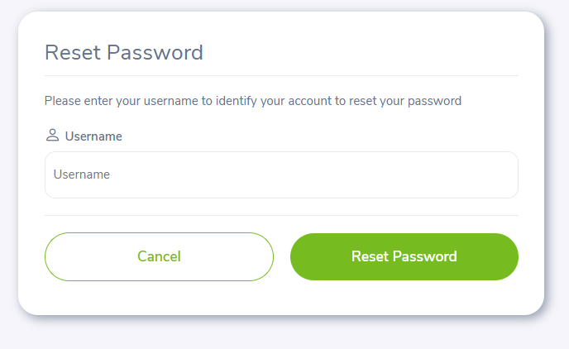
● Scenario ID: 1h
Scenario: Verify Logout Functionality
Test Steps: 1 After a successful login, click the user profile icon and select Logout.
Screen sort 